Muhaimin Ahmed

M00942607  Report for Project 2

Social networking site

Contents

Description of Project 2

Frontend Functionality 2

Welcome Page 2

Login Page 3

Register Page 3

Homepage 4

Search 4

Profile 5

Create a Post 7

Postman 7

Login 8

Users 8

Posts 10

# Description of Project

For my project I have decided to create a social media page for football fans. On the page the user is able to create an account and sign in. Once they have signed in the user is able to create posts, view posts, search for posts/users and view their profile. In their profile they are also able to follow/unfollow people and also view their follow list. They are also able to delete their account and logout.

# Frontend Functionality

Below I will show the pictures of the front end and the different features

## Welcome Page

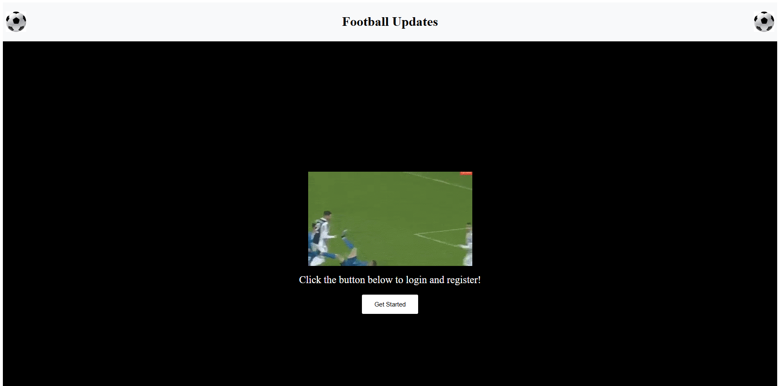

This is the welcome page for the user. This is the first page the user will see once they open the website. They can click the get started button to be moved onto the next page.

## Login Page

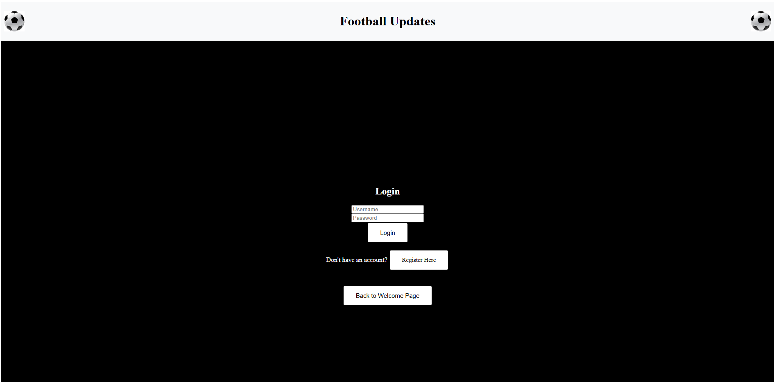

Once the user clicked the get started button this is the page they are directed to which is the login page. If the user wants to, they can click the back to welcome page button to be redirected to the welcome page or else they can continue to login or press the register here button to register an account.

## Register Page

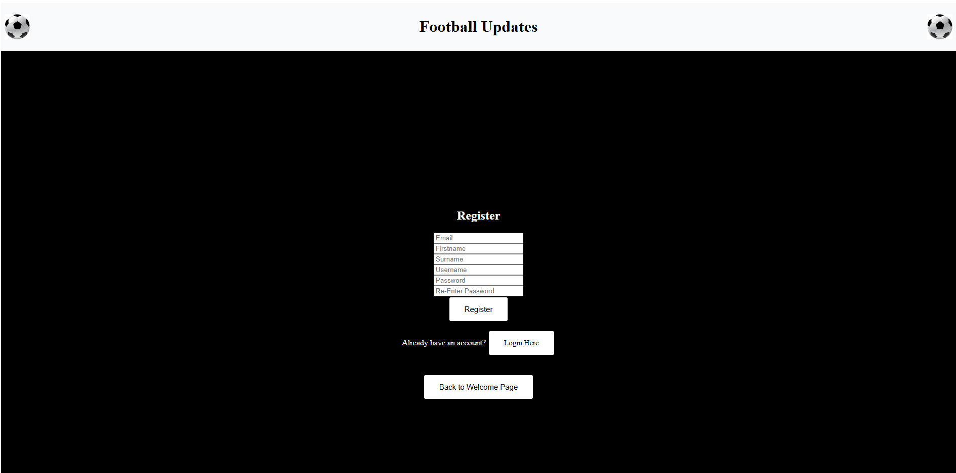

Once the user clicks the register here button, they are redirected to this page which is the registration page. Here the user can fill in their details to register an account.

## Homepage

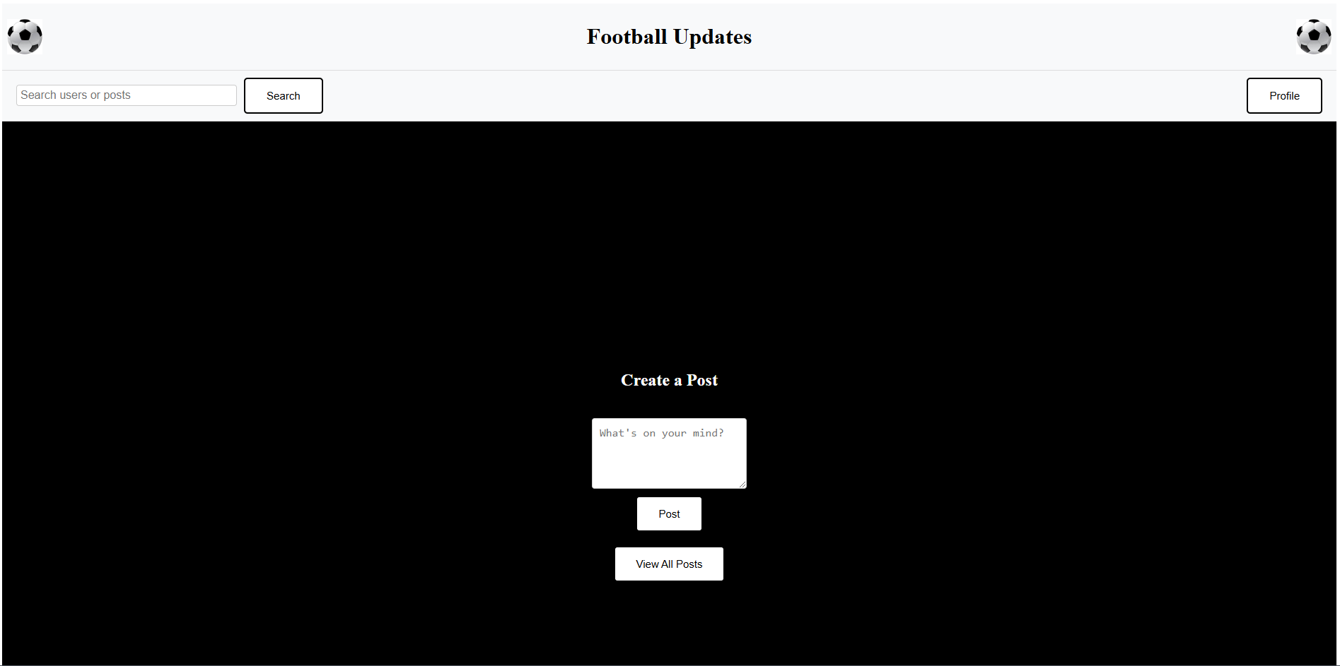

Once the user has logged in, they will see the homepage. In this page they can use the navigation bar to search for a user or a user’s posts or they can view and manage their profile. Below on the main screen they have the ability to create a post and upload an image (I was not able to get this working however I have left the code in the files to view). They also have the ability to view all posts.

## Search

In this section the user is able to search for a user and a post. I have attached to images below showing what it looks like once they have searched for a term. The first image is what is seen when just a term that has a user is searched for and the second is a term in a post.

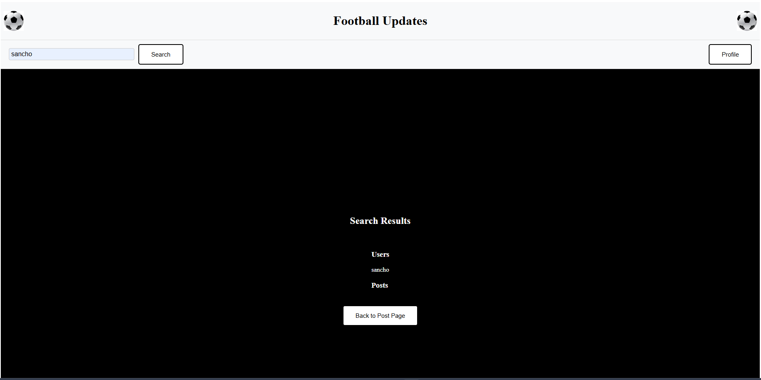

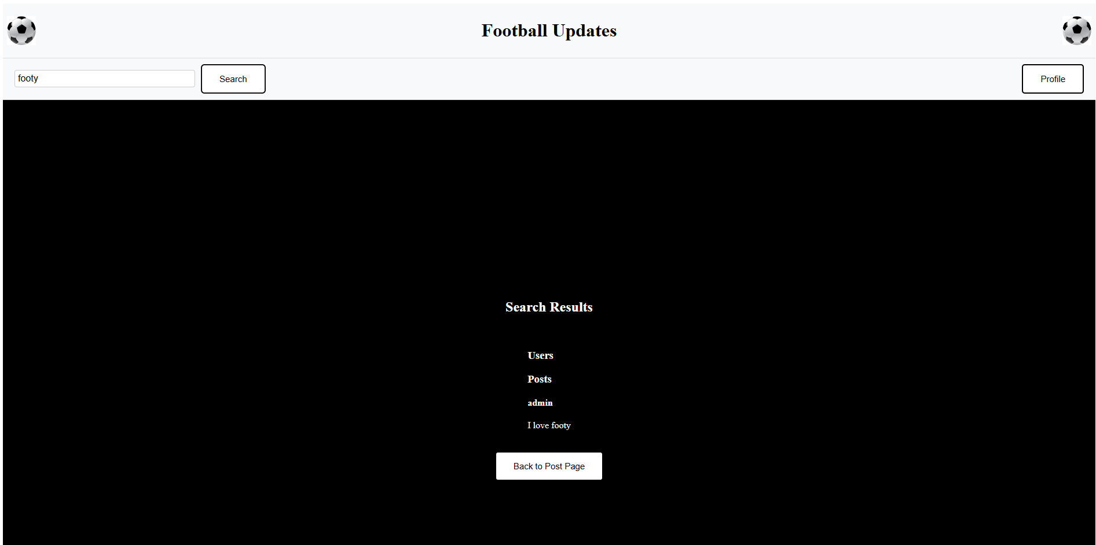

## Profile

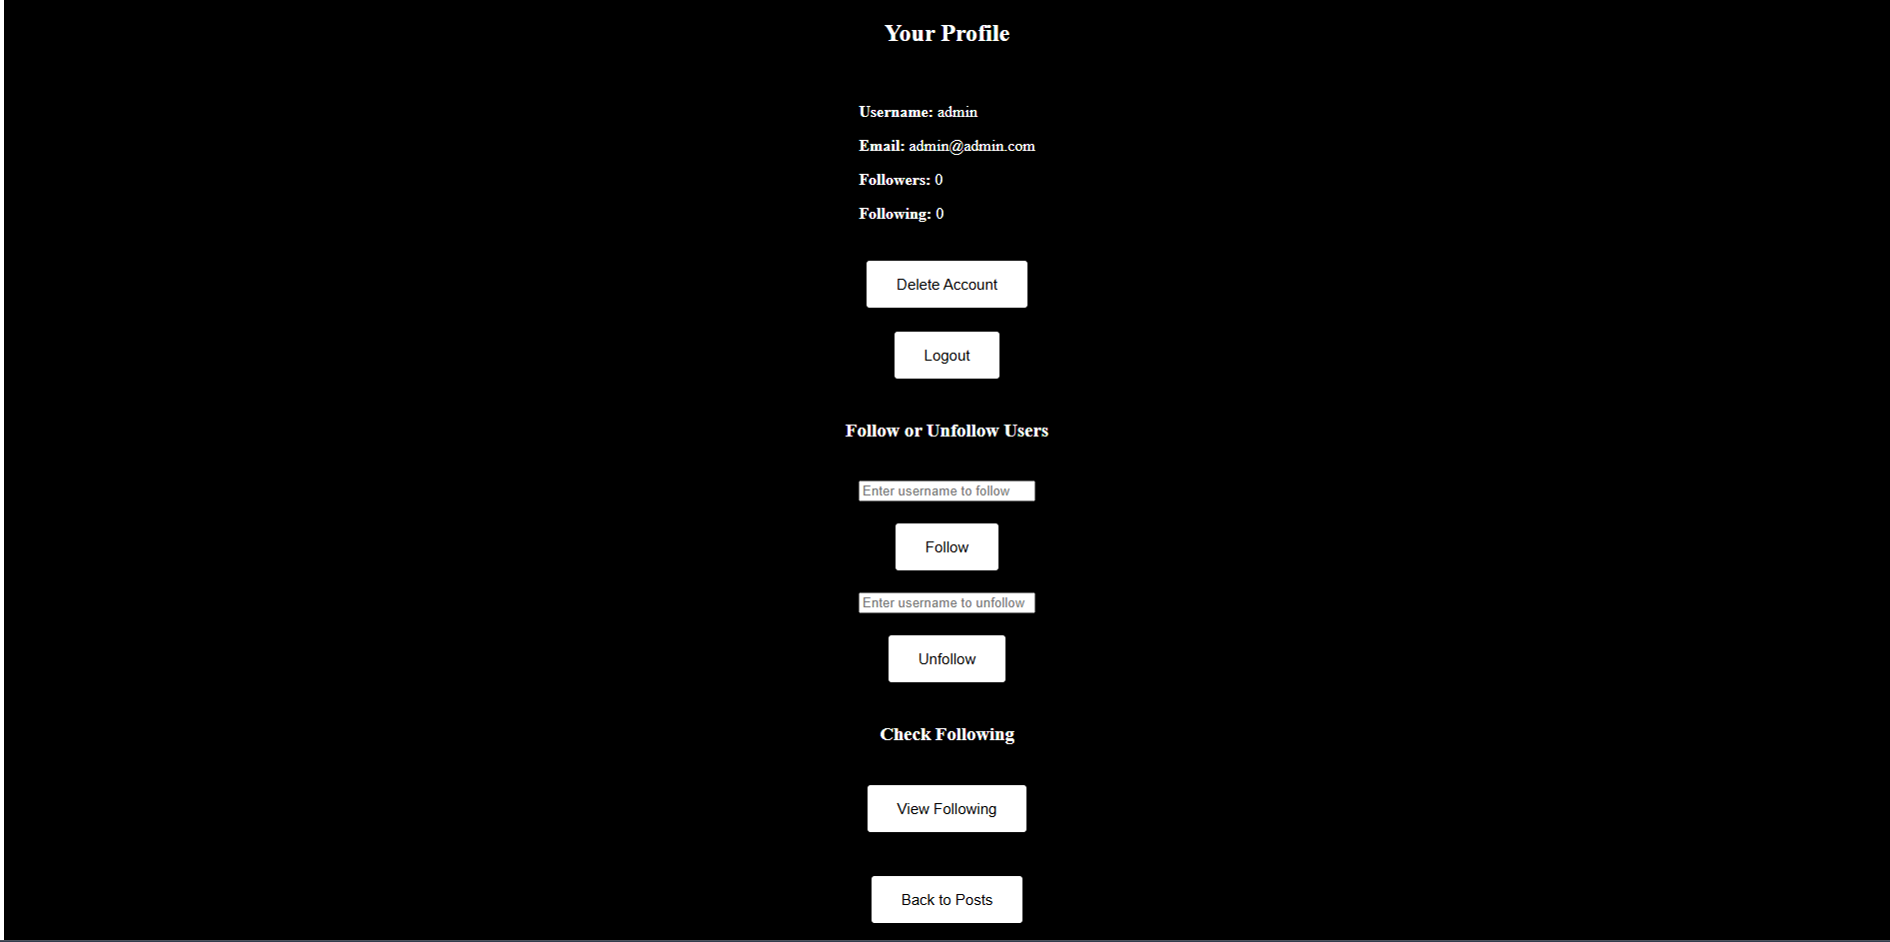

This is the page for the profile. In this page the user is able to see their details, they can delete their account and log out. They can also follow and unfollow users and also check their following. In the above screenshot the following is zero however after I follow someone the following count goes up.

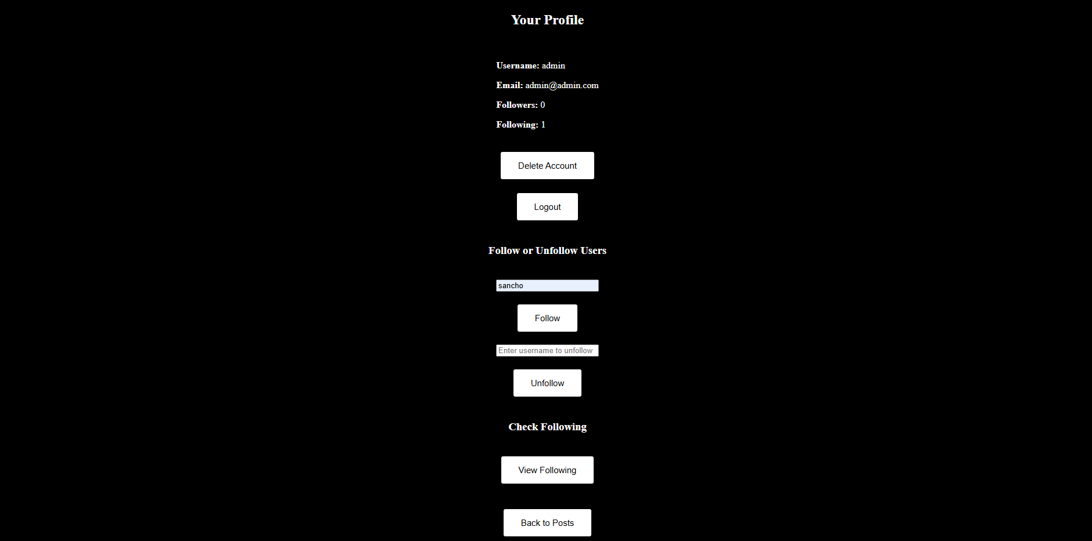

If I then continue to unfollow someone then it will go to 0.

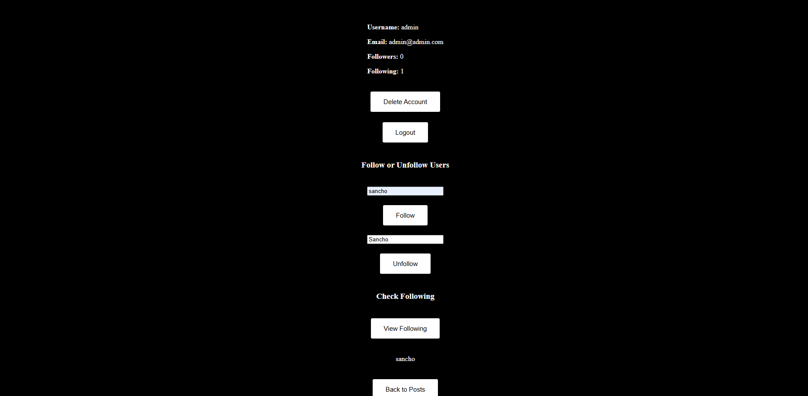

Once view following is clicked it will show who I am following.

## Create a Post

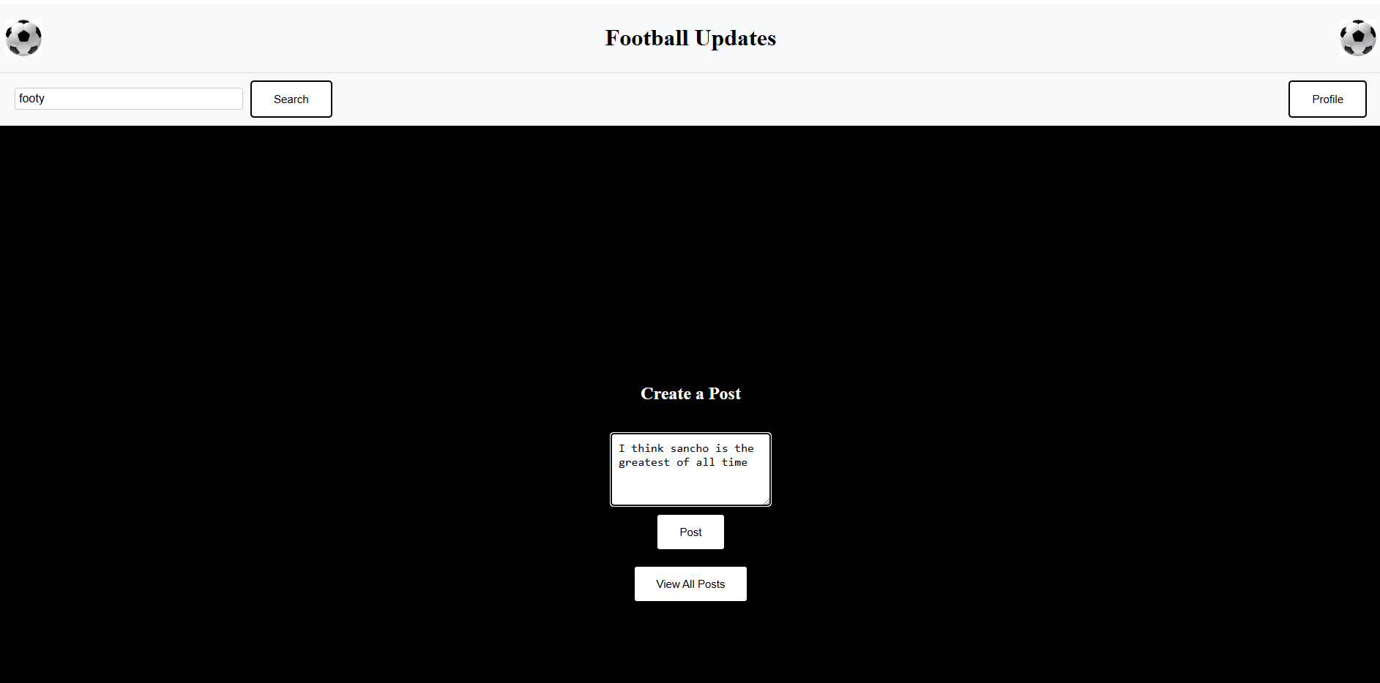

The user can write a text in the text box and then press post to post it.

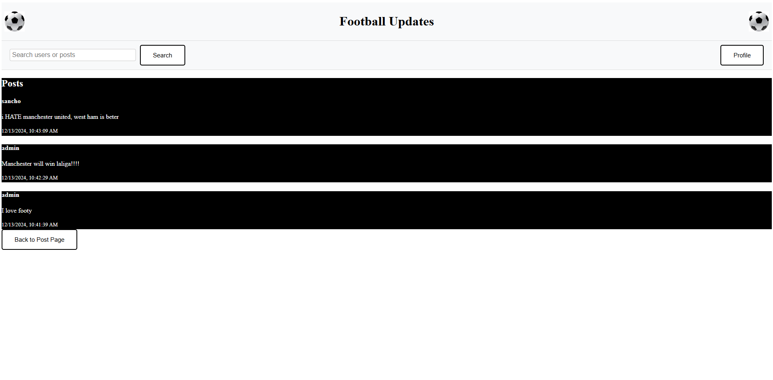

Here is the screenshot containing the screen with all the posts.

# Postman

Below are the screenshots for my postman.

## Login

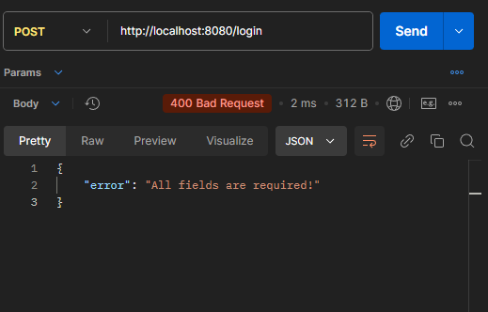

This is the postman for the login functionality.

## Users

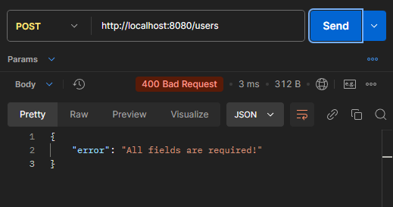

Thid is the postman for the registration functionality.

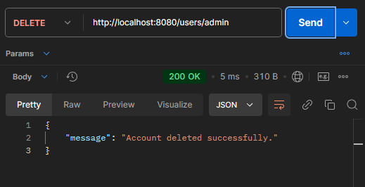

This is the postman to delete your account.

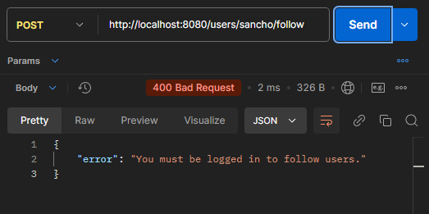

This is the postman to follow someone.

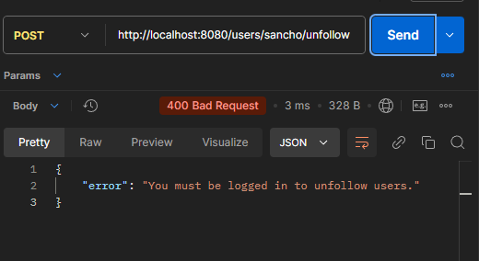

This is the postman to unfollow someone.

## Posts

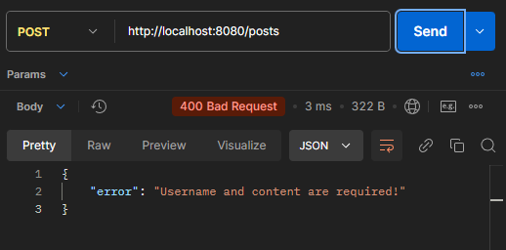

This is the postman to post something.